PRACTICAL FILE

# PROBABILITY AND STATISTICS (SPSS)

SUBJECT CODE : MC-205

MATHEMATICS AND COMPUTING

B.TECH SEMESTER-3



DEPARTMENT OF APPLIED MATHEMATICS

DELHI TECHNOLOGICAL UNIVERSITY

(FORMELY DELHI COLLEGE OF ENGINEERING)

SUBMITED BY : LOKESH GODARA

ROLL NO . : 23/MC/82

SUBMITED TO : Prof. Ramesh Srivastava

Mr. Yogesh Bhardwaj

# INDEX

|  |  |  |  |
| --- | --- | --- | --- |
| S.No. | Experiment | Date | Signature |
| 1. | Transportation of Data Set to SPSS Editor |  |  |
| 2. | Merging of Data set & providing missing values |  |  |
| 3. | Pictographical representation of data using Bar diagram and Pie chart |  |  |
| 4. | Drawing of Histogram and distribution curve |  |  |
| 5. | Descriptive Statistics |  |  |
| 6. | Correlation between two random variables |  |  |
| 7. | Regression Analysis |  |  |
| 8. | Hypothesis Testing ‘t’ - test |  |  |
| 9. | Chi Square test |  |  |
| 10. | ANOVA One Way |  |  |
| 11. | ANOVA Two Way |  |  |

# Experiment - 1

Objective: Transporation of Data Set to SPSS Editor

Resources: SPSS editor, Source file Proceedure And Methodology:

Open the spss editor window and follow the steps as shown below:

Case 1. Data from an excel file

## Commands: File > Open > Data> give file path

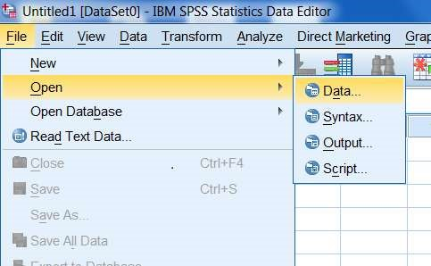

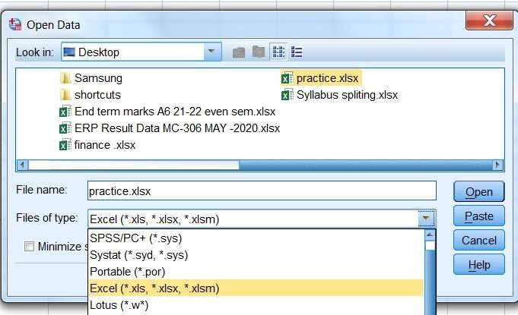

(select the requisite file extension)

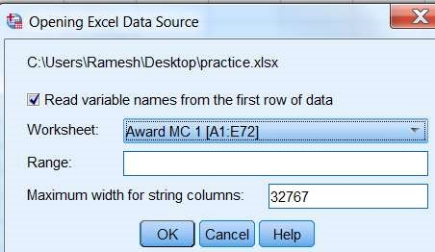 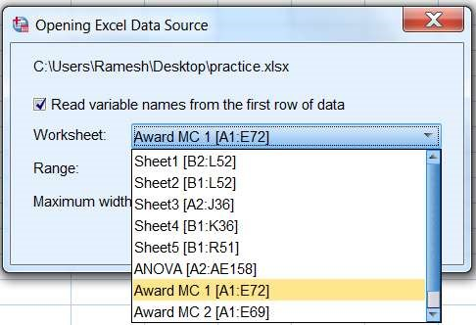

### Output Window

variable

view

Case 2

. Importing data from a text file.

Follow the command

File> Read Text Data> give file path

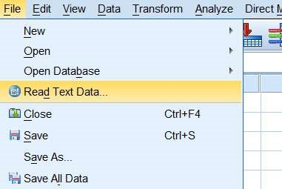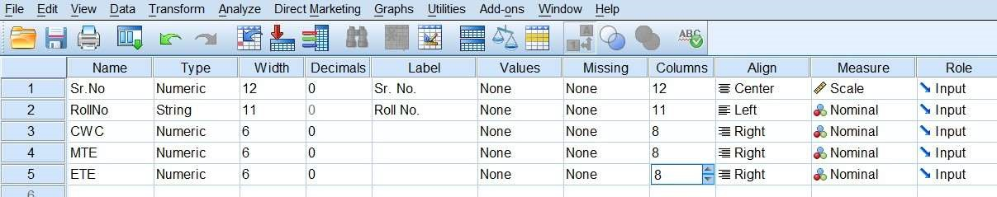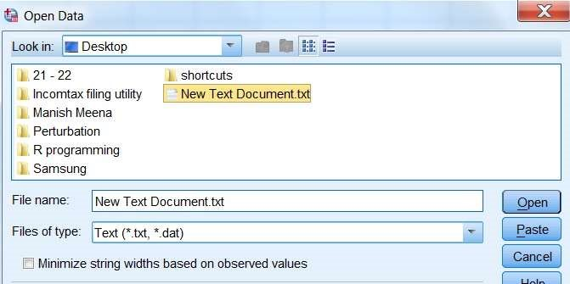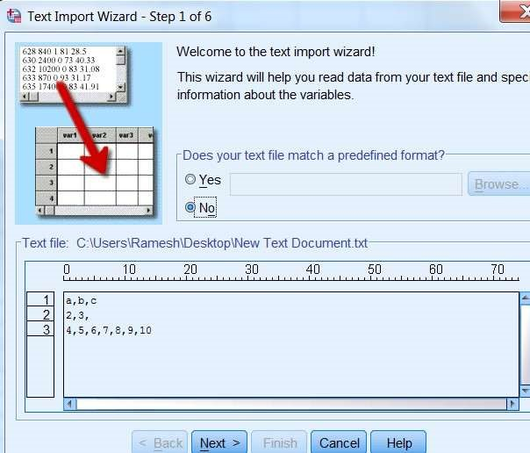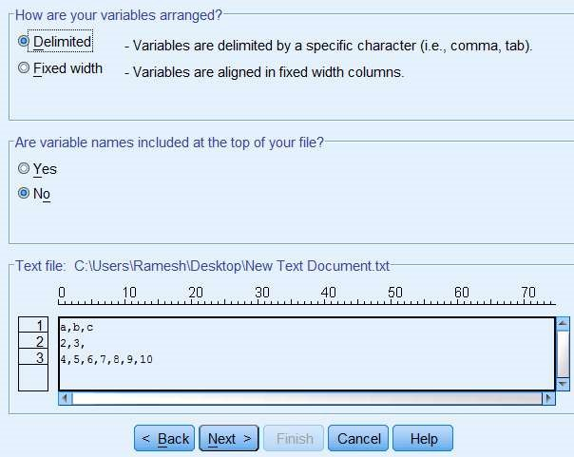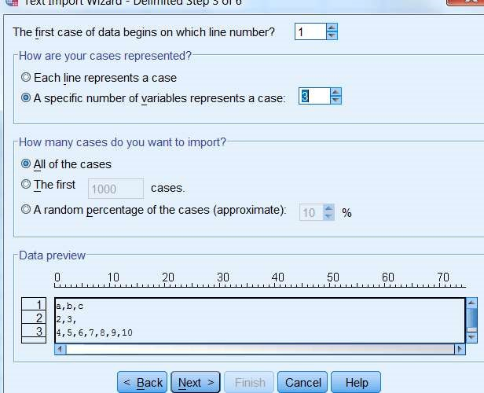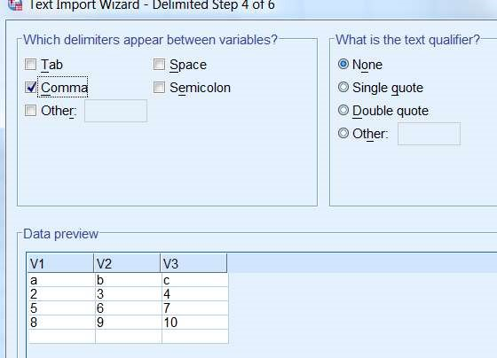

### Output window

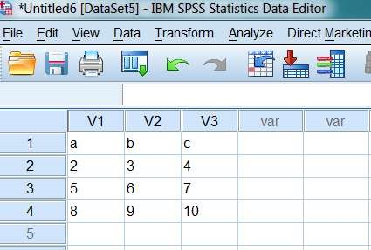

Conclusion:

Data from files in excel or text format can be transported to SPSS editor window.

Precautions:

1. There should be proper delimiter between data entry in text file.
2. Extensions of the files should be strictly taken care of.

# Experiment - 2

Objective: Merging of Data set

Resources: SPSS editor, Source files with .sav extension Proceedure And Methodology:

Case 1. Merging data as add cases.

Open the spss editor window and read the data of 1st file follow the steps as shown below: Sample files are origanally shown below

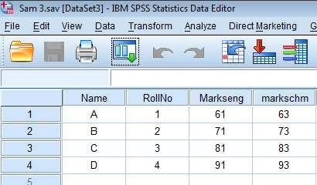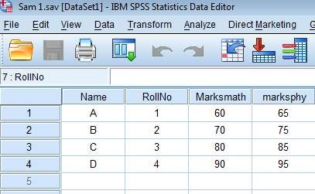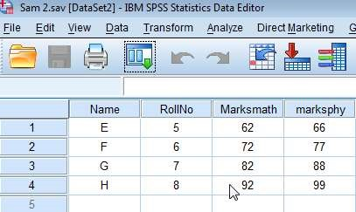

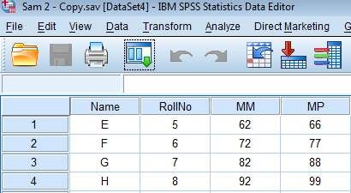

Case 1.1: Merging files with identical variable name

## Commands: File > Open > Data > sam1.sav

Merging sam2.sav in sam1.sav Data > merge file > add cases > browse>select file and click open

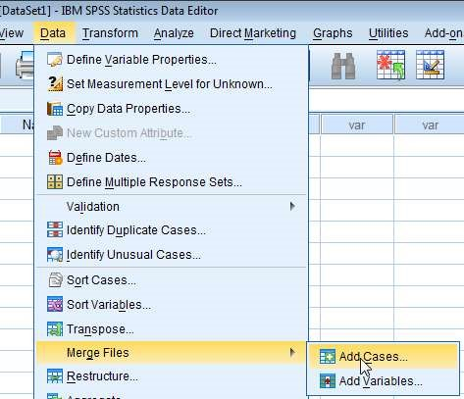

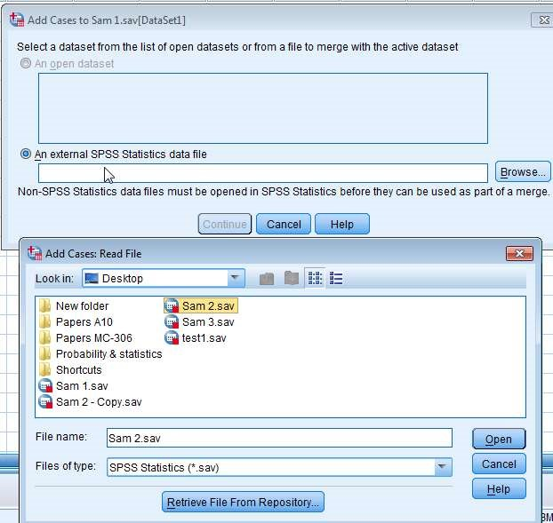

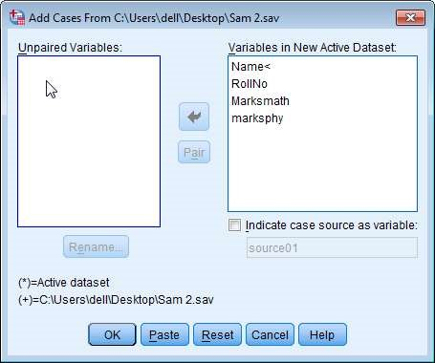

(both files are possessing the identical variable names)

Output window after merger.

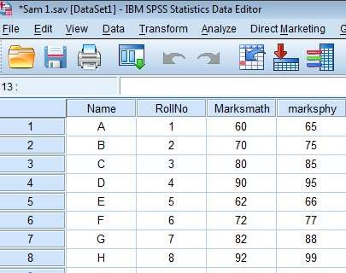

Case 1.2: Merging files with different variable name but same data

## Commands: File > Open > Data > sam1.sav

(Merging sam2.sav_copy in sam1.sav) Data > merge file > add cases > browse > select file

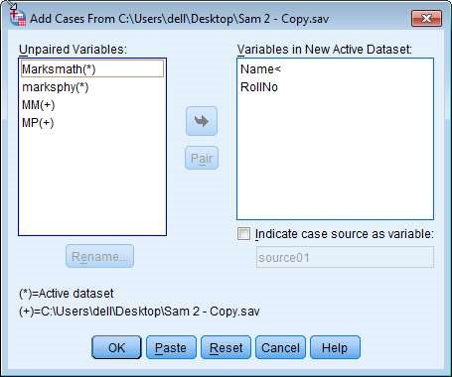

MM & MP contains the marks of math & physics but named different, so they are to be paired. Select both the variables to be paired and click pair.

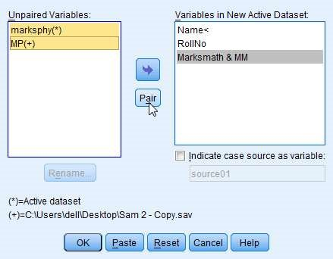

Doc Output window shows the execution.

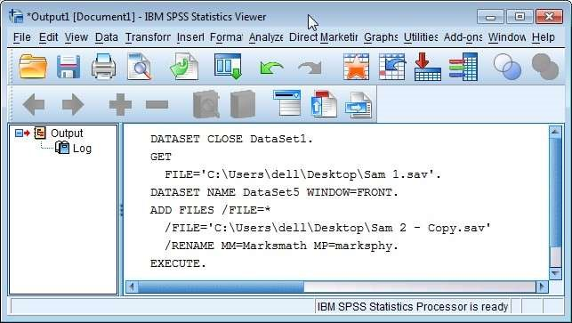

### Output window

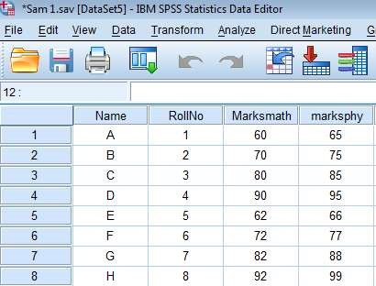

If the files are merged without pairing,

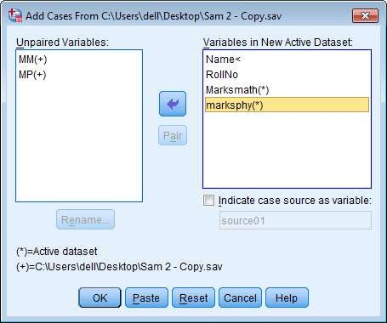

### Output without pairing

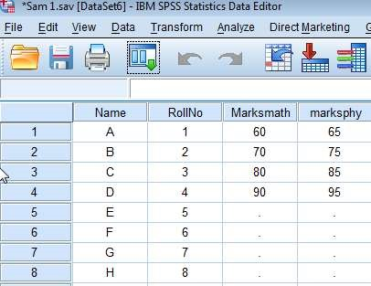

Dotted values are missing values. Names and roll no. are added but marks are not merged.

Case 2. Merging data as add variables.

## Commands: File > Open > Data> sam1.sav

Merging sam3.sav in sam1.sav Data > merge file > add variables > browse>select file

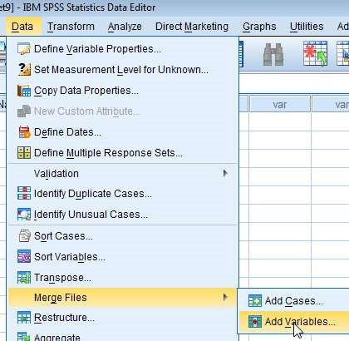

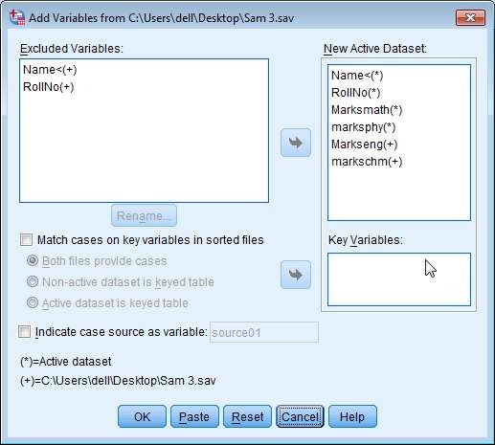

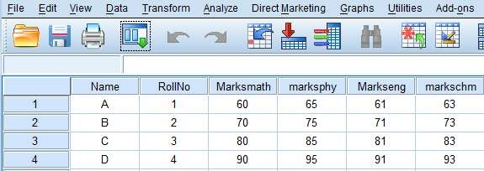

Providing missing values

Open the file with sav extension, containing missing value then follow the command transform > replace missing values

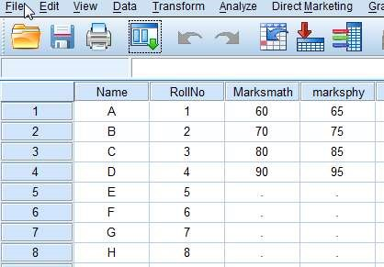

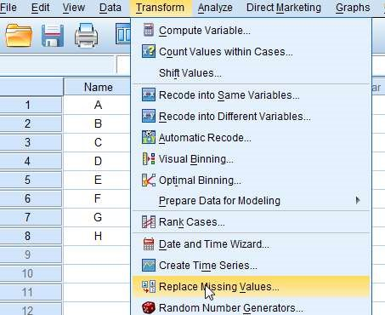

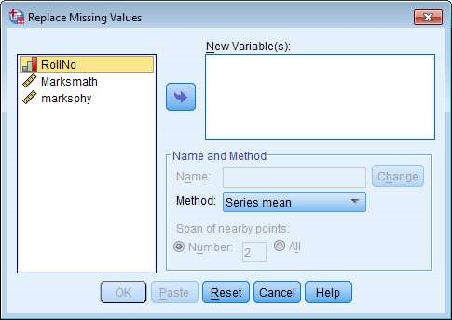

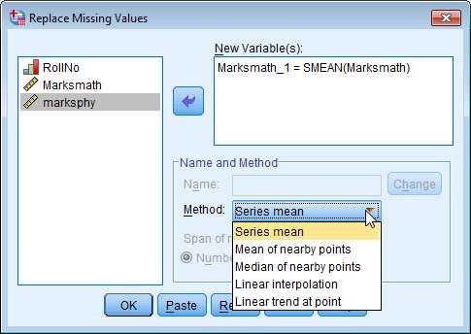

choose the method

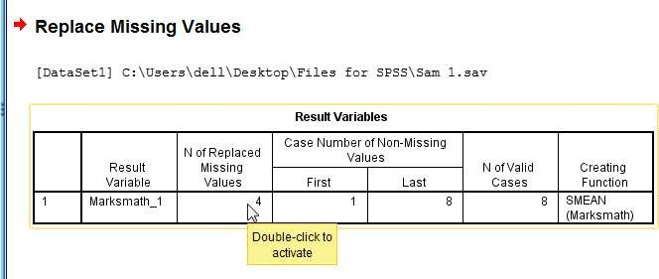

### Final data output window

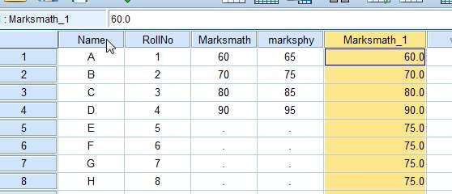

A new variable is created with missing value replaced by the mean of the series.

Conclusion:

Data files are merged by adding cases, and by adding variables. Also the missing values are replaced by (mention the name of method used)… ......... value.

Precautions:

1. Merger is possible only for .sav files, therefore each data should be first imported and saved in .sav file.
2. The pairing of the variables is to be done carefully.

# Experiment - 3

Objective: Pictographical representation of data using Bar diagram and Pie chart

Resources: SPSS editor, Data Source file .

Proceedure And Methodology

A pictographical representation of data helps in quick and better interpretation of the data.

Case1. Bar diagram

Open the desired file in SPSS editor File > Open > file path

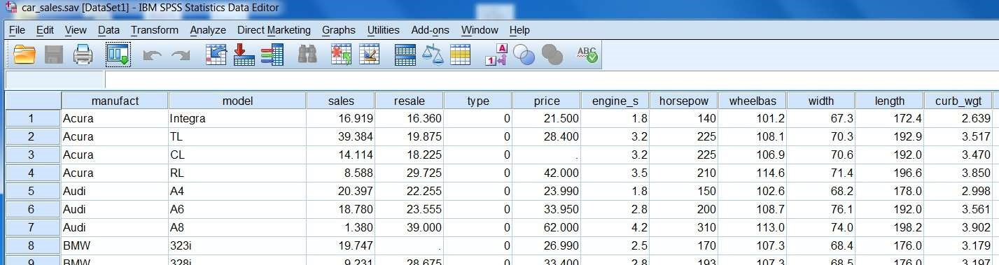

## This is car_sales data and we are to plot a bar diagram for the Horse Power

Go to Graph > Chart Builder and click (charts can be drawn using legacy dialogs also )

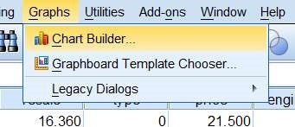

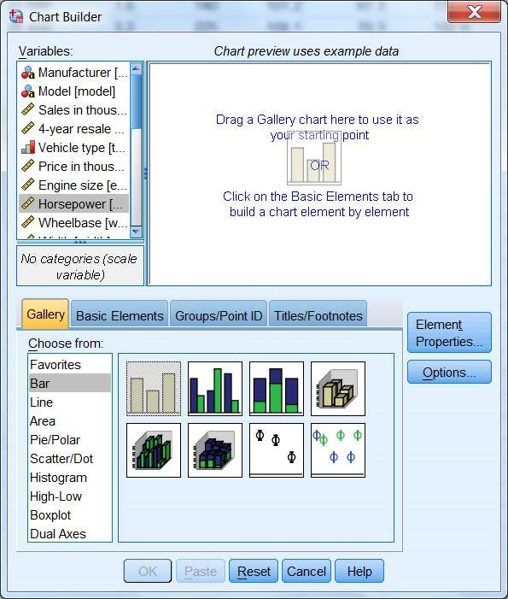Select the variable Horse Power then Bar and then drag the picture of bar in chart preview area.

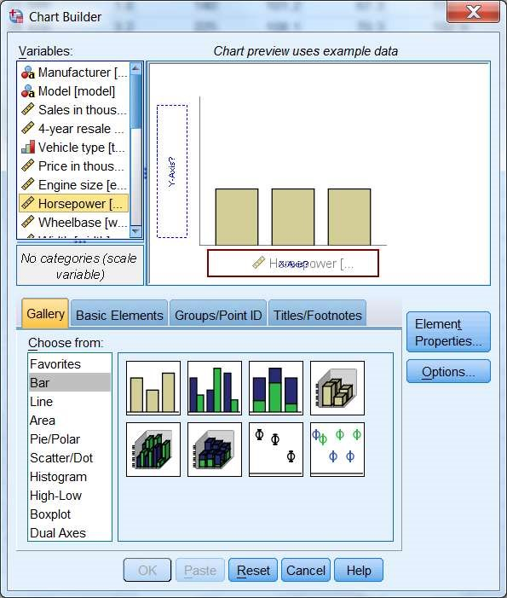

Drag Horsepower to

horizontal box and click OK

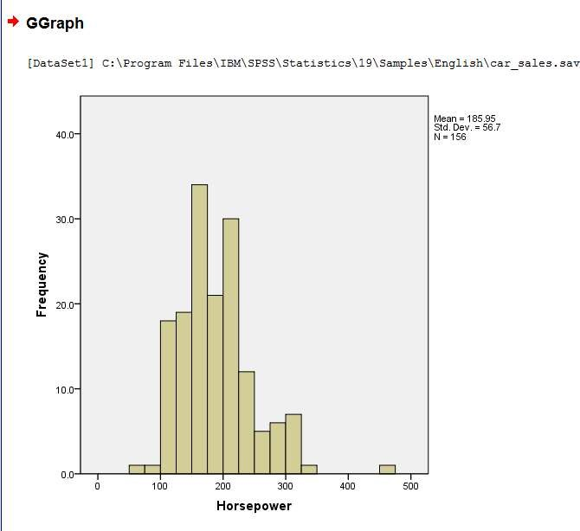

Double click the at graph area and it will go in editable mode

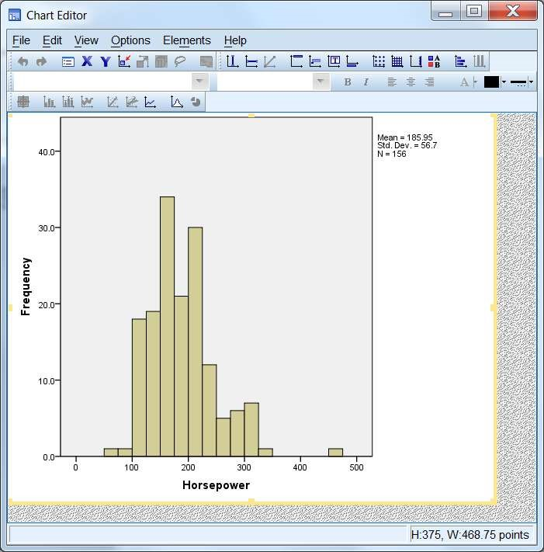

To which part you want to edit double click and a dialog box will open to edit

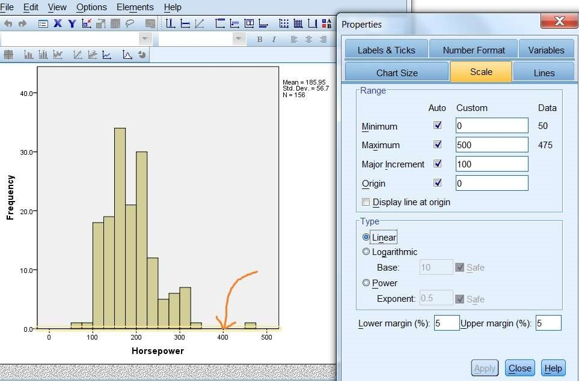

e.g. Horizontal axis is selected for editing.

Case2. Pie chart

After opening the file go to Graph > Chart Builder the select the chart type Pie

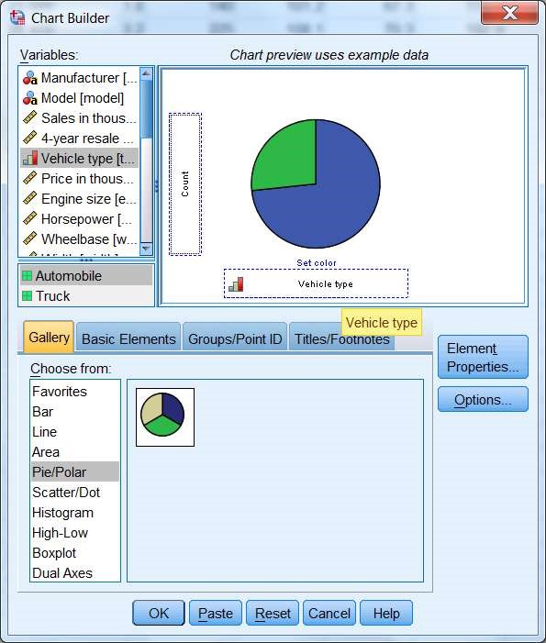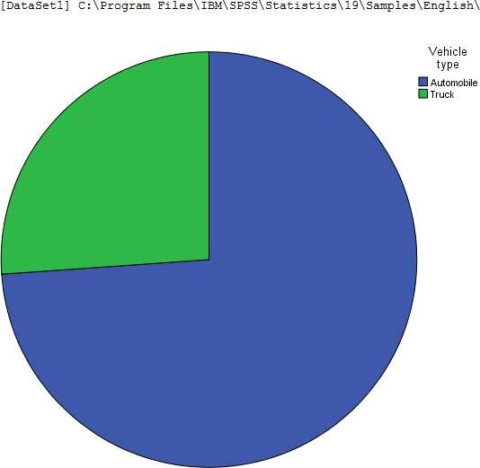

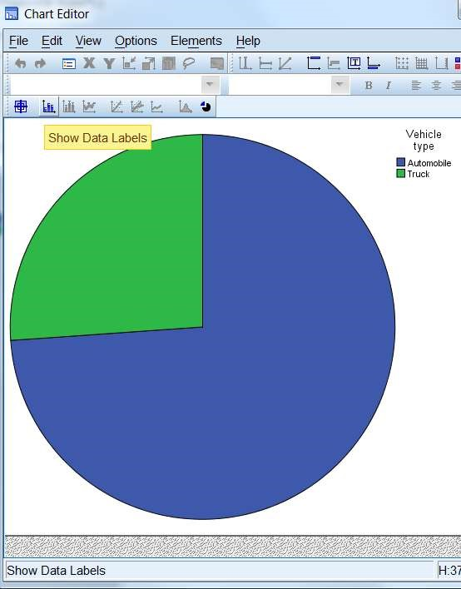

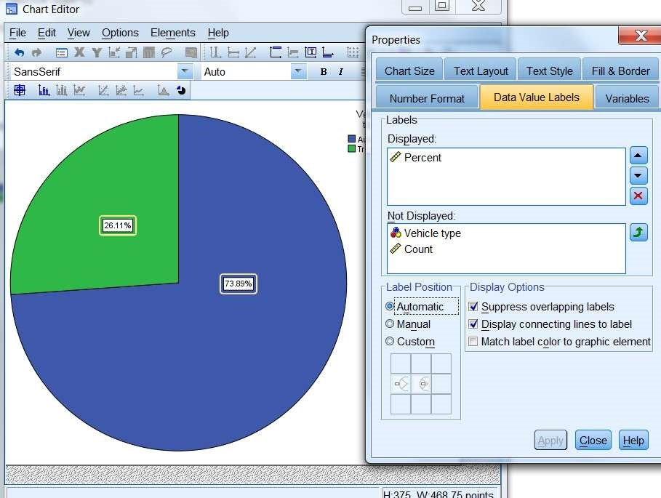

Conclusion:

The Data set of Car sales from repository is used, and the bar diagram of Horse power of engine variable and Pie chart of Type of vehicle variable is successfully drawn. Precautions:

1 The variable property should be defined carefully.

2. Missing values if any should be taken care of.

# Experiment - 4

Objective: Drawing of Histogram and distribution curve

Resources: SPSS editor, Data Source file.

Proceedure And Methodology

Data is arranged in a table with respective frequency. Then Histogram is drawn. The curve obtained by joining the middle point of each bar gives us frequency curve.

Histogram

Open the desired file in SPSS editor File > Open > file path

(car_sales.sav from repository is used & the variable Horsepower is considered for frequency) Transform > visual Binning > enter

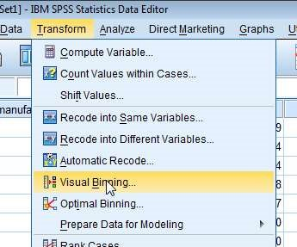

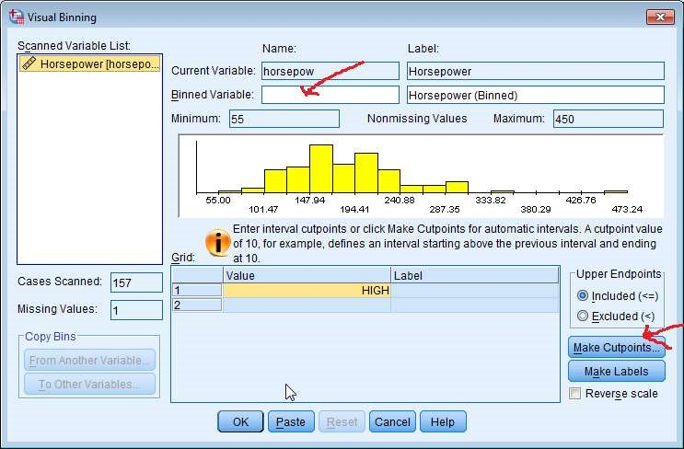

Provide a new name for variable. Then click make cut points.

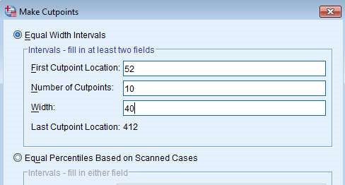 give desired values then OK

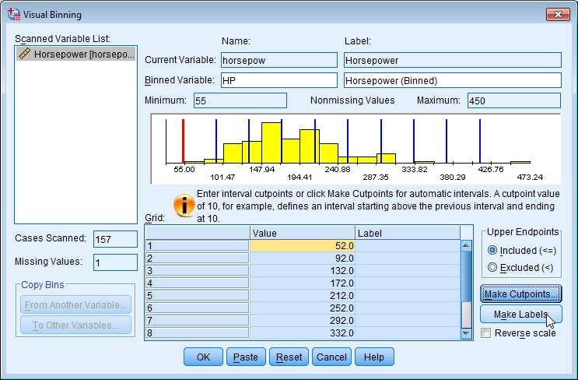

HP is new name given to variable. Click Make Labels to display the class interval

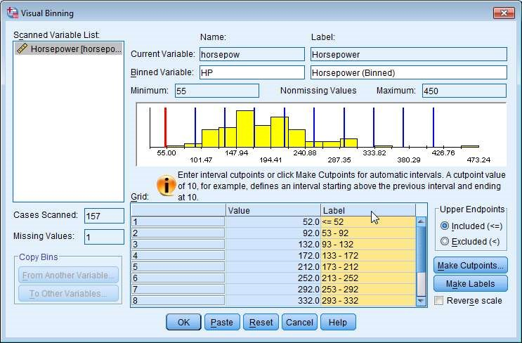

Then OK.

A document window will open describing the execution.

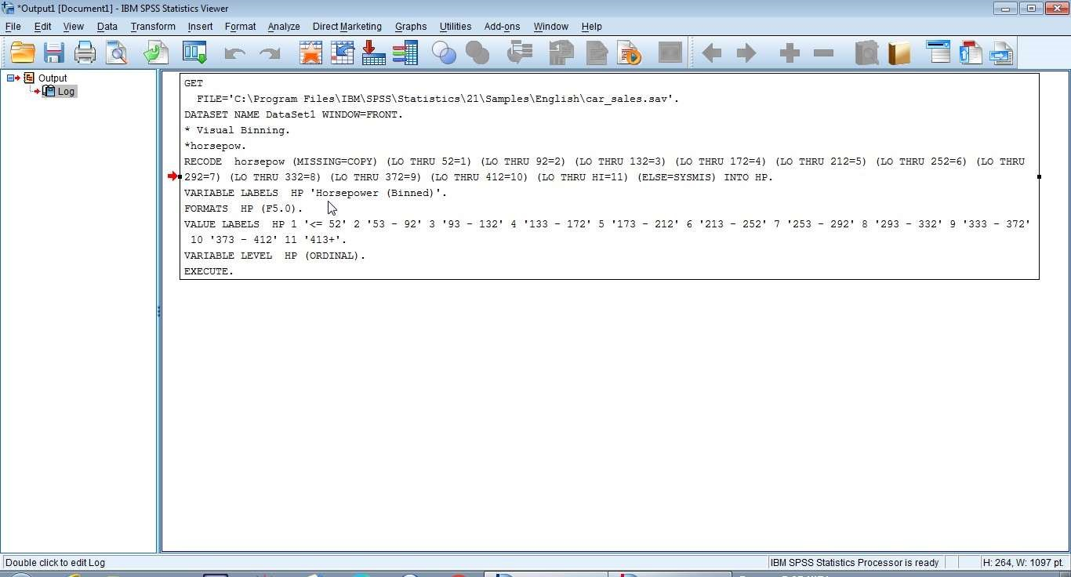

A new variable HP (Horsepower Binned) will be present in editors view. In Fig.1 the class intervals are displayed and in Fig.2 frequencies are displayed. You can toggle between these two by clicking

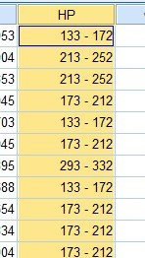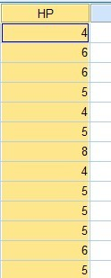

Fig.1 Fig.2

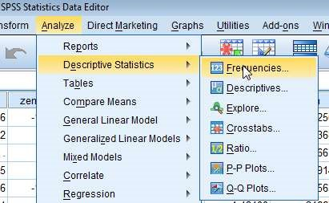

Transfer the variable for which frequencies are to be obtained.

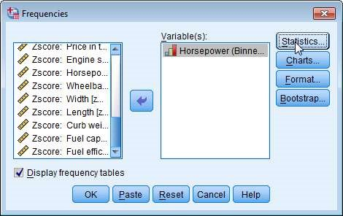

click Statistics

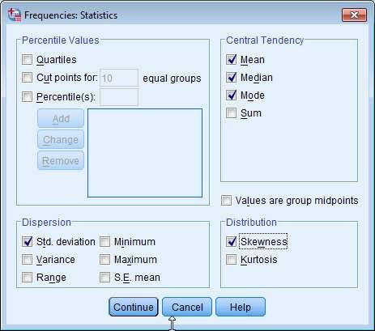

select the desired options and continue. Then click Charts and select Histogram.

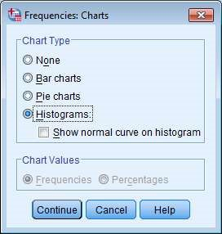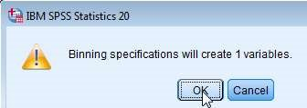

Doc window showing Statistical details

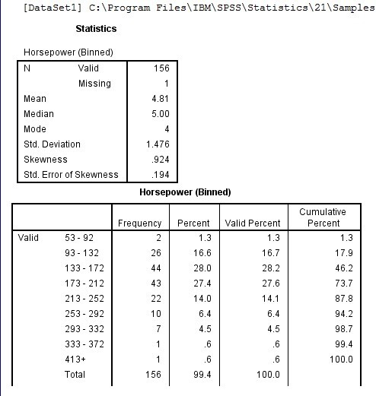

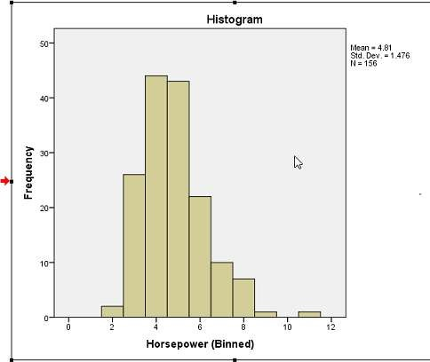

Histogram may be edited by double clicking it.

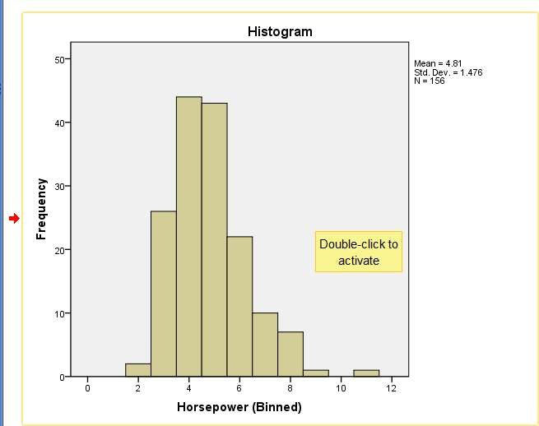

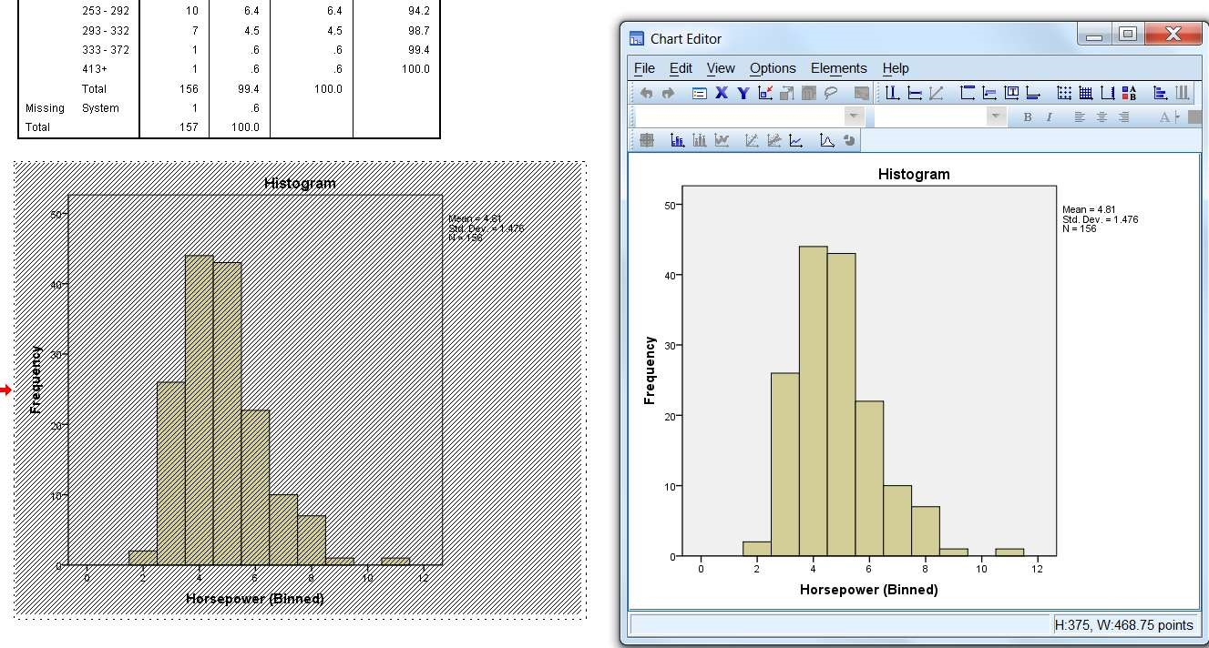

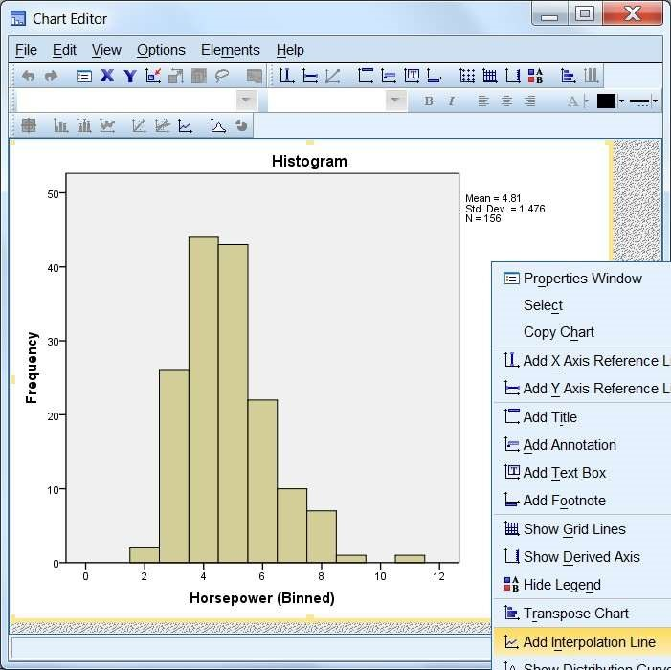

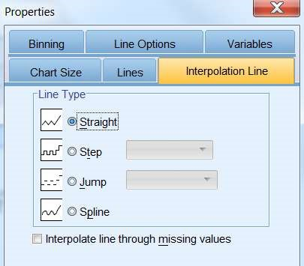

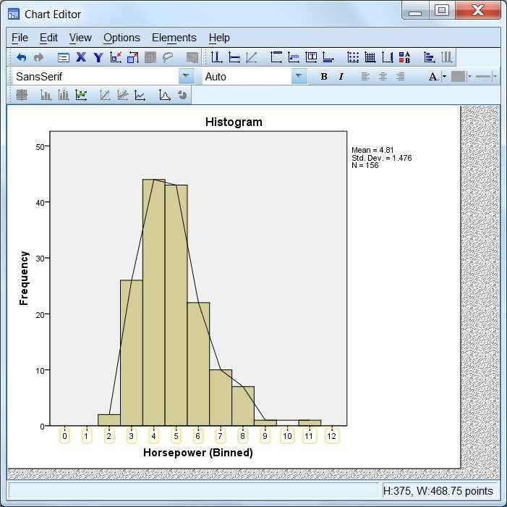

Conclusion:

The Data set of Car sales from repository is used, and frequency table is created. Then the Histogram and frequency curve of Horse power of engine variable is successfully drawn. Discuss about class interval and the information revealed by frequency table, histogram and frequency curve Precautions:

1. The class interval should be decided carefully so that no critical information of variable property is lost.
2. Missing values if any should be taken care of.

# Experiment - 5

Objective: Descriptive Statistics

Resources: SPSS editor, Data

Source file. Theory And

## Methodology

The various statistical constants are to be calculated and interpreted.

𝑥1 + 𝑥2 + ⋯ +𝑥𝑛 ∑𝑛 𝑥𝑖

𝑠𝑎𝑚𝑝𝑙𝑒 𝑚𝑒𝑎𝑛 (𝑥̅) = = 𝑖=1

𝑛 𝑛

Median (𝒙̃)

The point in the data set dividing it into two halves is called median.

### Mode

It is the value which occurs with the greatest frequency (maybe more than one value). In case of grouped frequency it is given as

### Variance and standard deviation

1. 𝑛
2. 2

𝜎 = ∑(𝑥𝑖 − 𝑥̅)

𝑛 𝑖=1

Skewness: Skewness is the measure of deviation from symmetry. The Karl-Pearson's Coefficient of Skewness is given as

𝑚𝑒𝑎𝑛 − 𝑚𝑜𝑑𝑒

𝑆. 𝐷.

Open the desired file in SPSS editor File > Open > file path

(car_sales.sav from repository is used & the variable Price in thousand is considered for descriptive statistics)

Case1. Statistical values when all type of cases together.

Then Analyze > Descriptive Statistics > Descriptives...

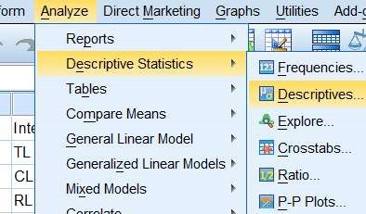

Choose the required variable (price in thousand) > option and check the desired boxes.

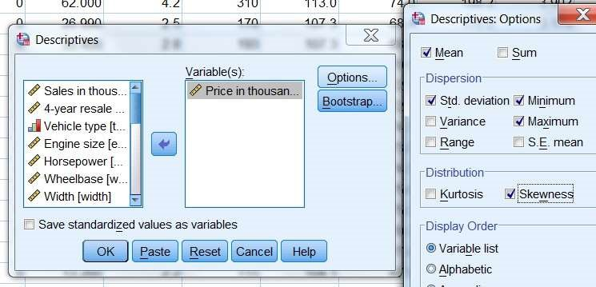

#### Document output window

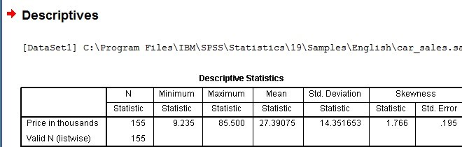

Now follow the path

Analyze > Descriptive... > Frequencies

Choose desired variable

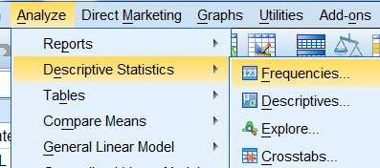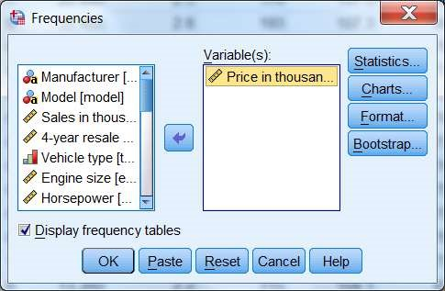

Click Statistics

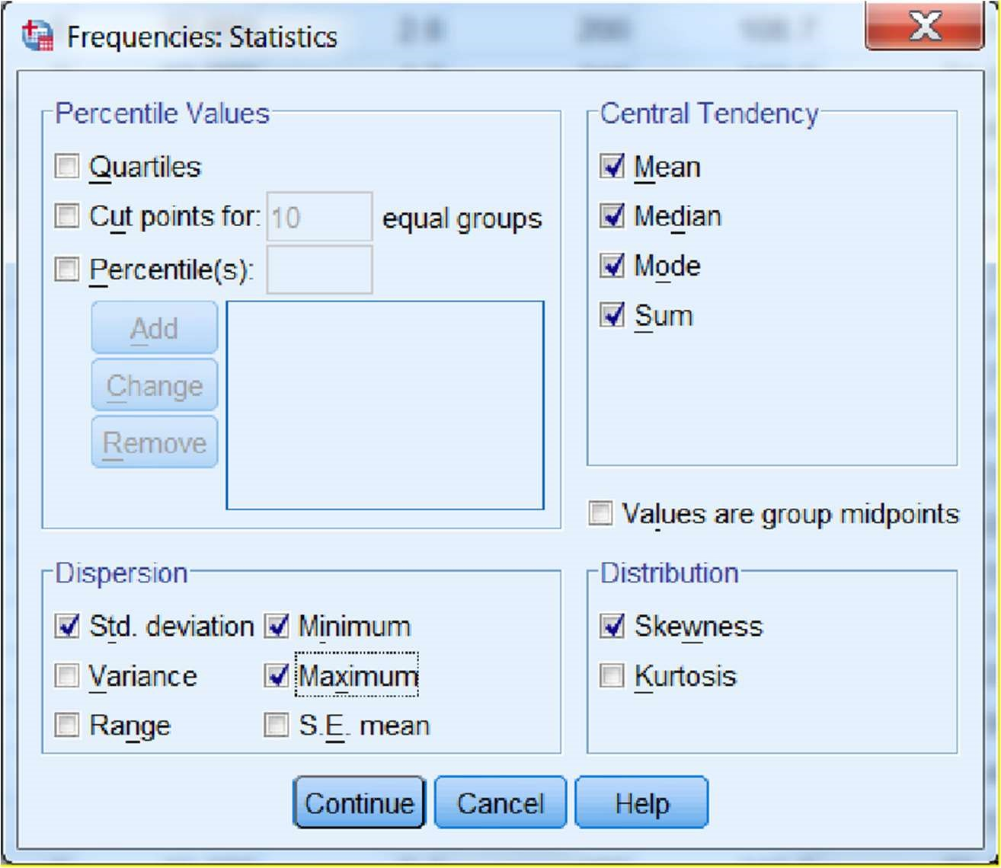

Check the desired boxes, then continue. Click Charts button

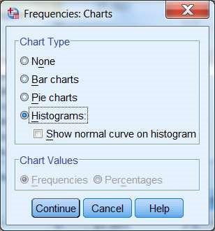

select the desired chart type (if chart is not required choose None).

#### Document output window

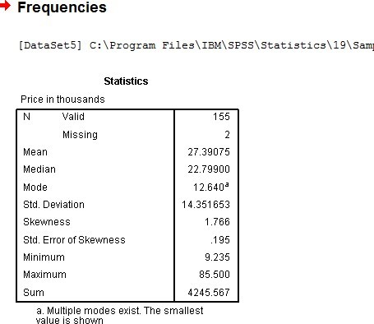

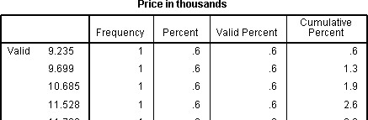

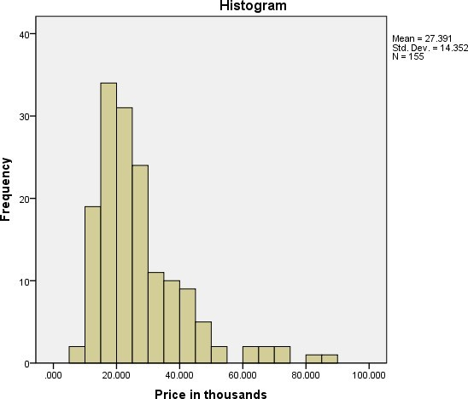

Histogram cab be edited by double clicking it.

(Observe the difference of information provided by two mode of retrieving statistical constants.)

Case2. Statistical values for all type of cases separately.

Suppose we are interested to have the statistical details with respect to all type of manufacturer separately then follow Data > Split file

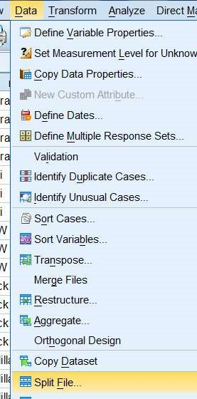

Select the desired variable (e.g. manufacturer) for which the splitter information is to be obtained, also select organize output by groups.

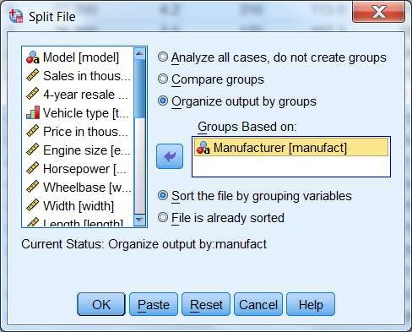

#### Doc output window

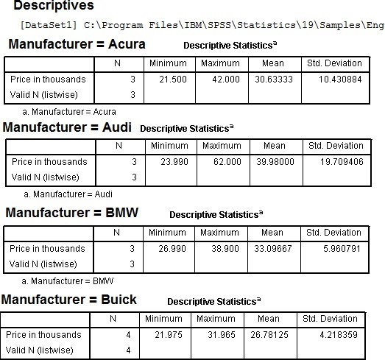

Conclusion:

The Data set of Car sales from repository is used, and Descriptive statistical table is created. Also the (name of the chart) (Histogram) of Price in thousand variable is successfully drawn.

Separate statistical summary of different manufacturers are also obtained

Precautions:

1. Variable Properties are to be defined carefully.
2. Missing values if any should be taken care of.

# Experiment - 6

Objective: Correlation between two random variables.

Resources: SPSS editor, Data Source file.

Theory And Methodology

As a measure of intensity or degree of linear relationship between two variables Karl Pearson coefficient of correlation denoted as 𝑟𝑥𝑦 𝑜𝑟 𝑟(𝑋, 𝑌) between two random variables 𝑋 & 𝑌 s defined as

If (𝑥𝑖, 𝑦𝑖) , 𝑖 = 1,2, … 𝑛 is the bivariate distribution, then

∑(𝑥 − 𝑥̅)(𝑦 − 𝑦̅) ∑ 𝑥𝑦 − ∑ 𝑥 ∑ 𝑦

𝑟𝑥𝑦  𝑖 𝑖 𝑛

=

=

√

∑

𝑖

(

𝑥

𝑖

−

𝑥

̅)

𝑦

𝑖

−

𝑦

̅)

2 √∑𝑖( 2 √∑ 𝑥2 − (∑ 𝑥)2 √∑ 𝑦2 − (∑ 𝑦)2

𝑛 𝑛

Open the desired file in SPSS editor File > Open > file path

(car_sales.sav from repository is used and the variables Horsepower of the engine & Fuel efficiency is considered)

Case1. Missing values dealt as Exclude cases pairwise Now follow the path Analyze > Correlate > Bivariate

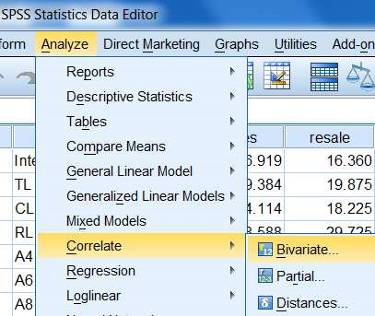

Choose the desired variable

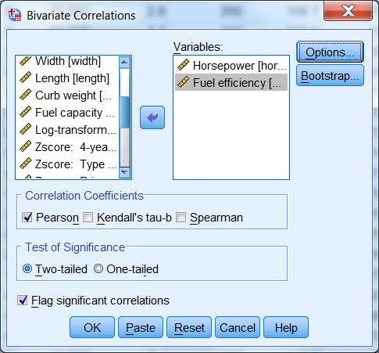

Click option and check the desired boxes.

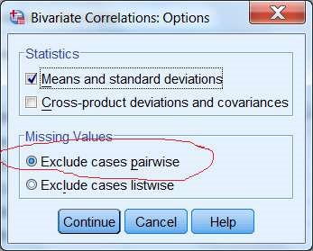

(Observe the selection for missing values)

## Document output window

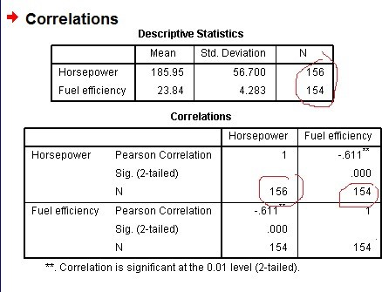

Observe in the descriptive statistics number of entry in Horse power and Fuel efficiency is 156 and 154 respectively. The total data points are extended to 157 points.

Case2. Missing values dealt as Exclude cases listwise

Now follow the path Analyze > Correlate > Bivariate

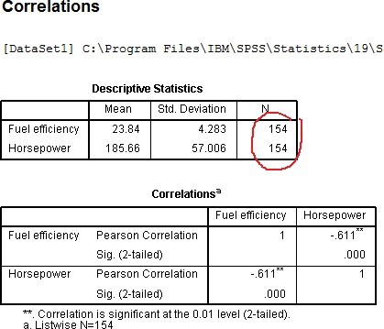

Choose Exclude cases listwise option for missing values

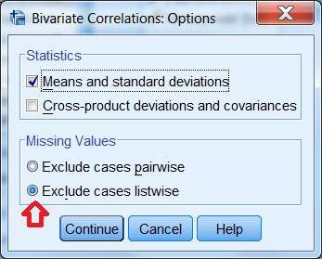

## Document output window

Case3. Missing values dealt before calculation of correlation

(Note : if the missing values are dealt before finding the correlation by series mean, then the total number of cases has become 157)

## Document output window

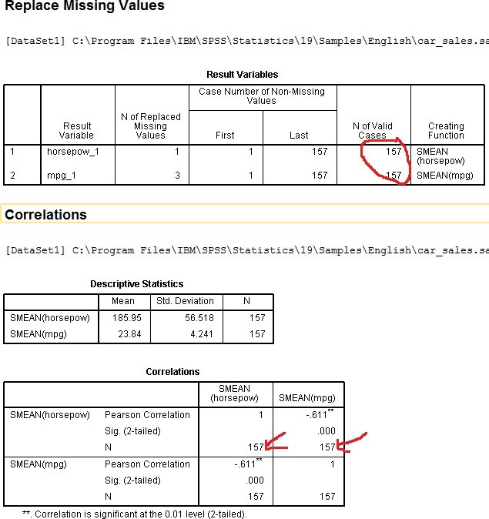

Conclusion:

The Data set of Car sales from repository is used, and correlation between the variables () Horse power and Fuel efficiency is found to be ........ Explain further the correlation coefficient value according to sign and its value.

Precautions:

1. Variable Properties are to be defined carefully.
2. Missing values if any should be taken care of.

# Experiment - 7

Objective: Regression Analysis

Resources: SPSS editor, Data

Source file. Theory And

## Methodology

Let (𝑥𝑖, 𝑦𝑖) , 𝑖 = 1,2, … 𝑛 be a bivariate sample, assuming one of them Independent say(x) and other dependent on first say(y), we predict the value of 𝑦 by fitting a curve to data. If the curve is line then it is called line of regression and there is said to be a linear regression.

The curve fit for Y on x is called regression curve of y on x and similarly curve fit for X on y is called regression curve of x on y

Let the line of regression of 𝑌 𝑜𝑛 𝑥 be

𝑌 = 𝑎 + 𝑏𝑥

Open the desired file in SPSS editor File > Open > file path

(car_sales.sav from repository is used and the variables Horsepower of the engine & Fuel efficiency is considered)

Case1. Using curve fitting path

Now follow the path Analyze > Regression > Curve Estimation

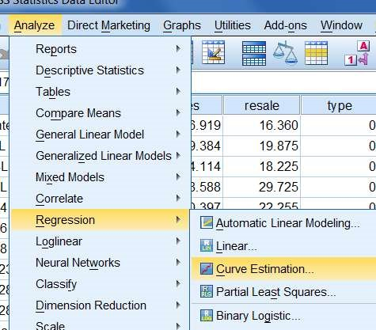

Choose dependent and independent variables and check the other desired boxes (Linear Model). Click save

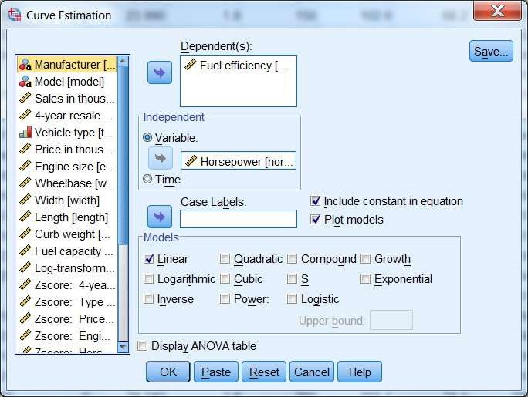

Check the predicted values

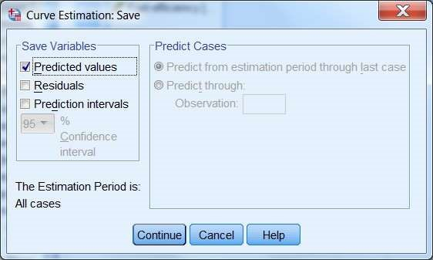

Document output window

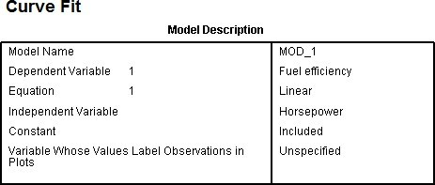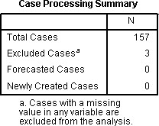

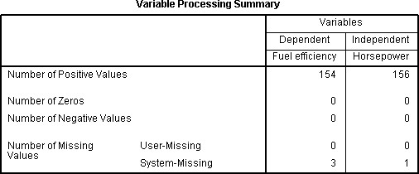

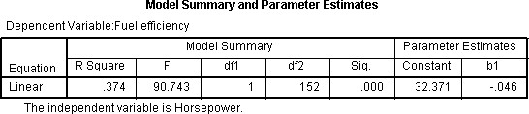

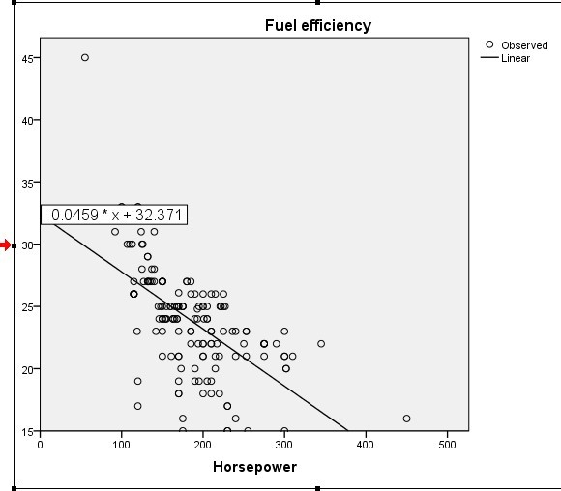

Also in data sheet a new variable for predicted values has been created.

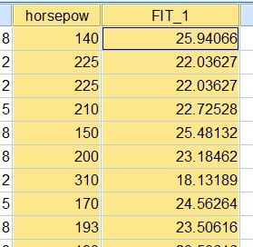

Case2. Using Linear Model approach

Now follow the path Analyze > Regression > Linear

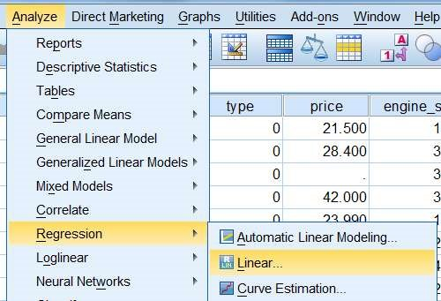

Choose dependent and independent variables and click statistics

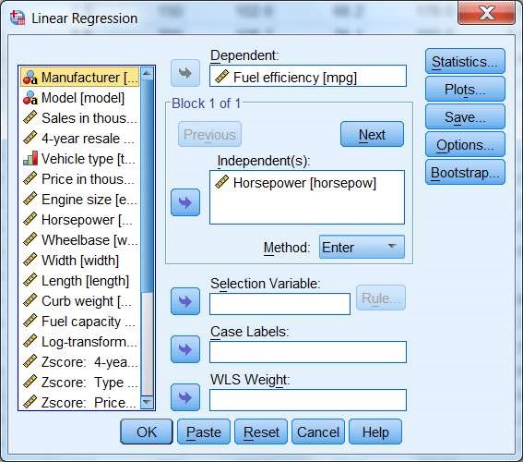

Check the desired boxes and continue

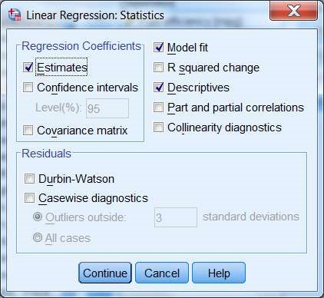

Click Save and check the desired boxes

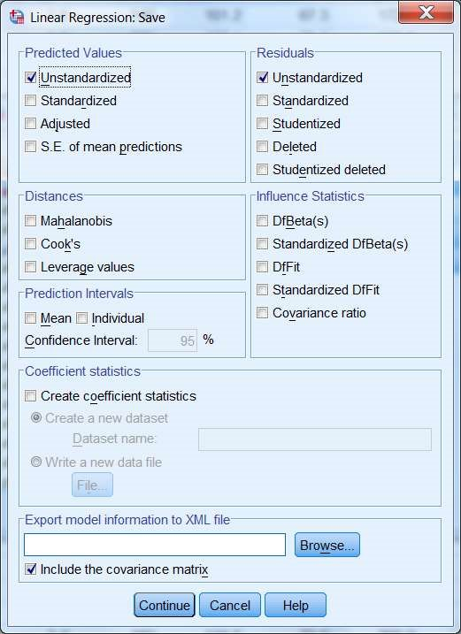

Click Option

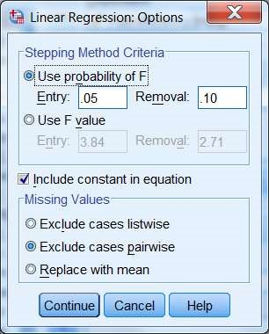

Decide carefully for treating the missing values.

### Doc output window

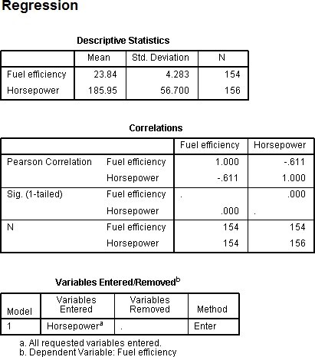

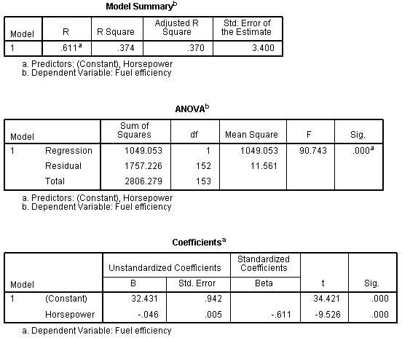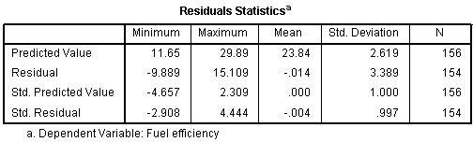

Two new variables for predicted values (PRE_1) and difference between predicted and actual (RES_1) have been created.

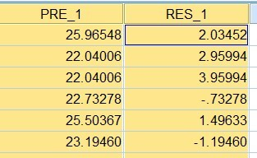

(There are various plot options also available and can be drawn as per need under plot button)

Conclusion:

The Data set of Car sales from repository is used, and a regression line fitted between the variables (Horse power-independent variable and Fuel efficiency-dependent variable). the value of constant is.... and coefficient is .......... Explain further the regression line properties exhibited in the case. Precautions:

1. Variable Properties are to be defined carefully.
2. Missing values if any should be taken care of.

# Experiment - 8

Objective: Hypothesis Testing ‘t’ - test Resources: SPSS editor, Data

Source file. Theory And

## Methodology

Null Hypothesis : Any hypothesis we wish to test and is denoted by 𝐻0 (hypothesis of no difference)

Alternative Hypothesis : Any hypothesis which is complementary to null hypothesis is called and alternative hypothesis, denoted by 𝐻1

‘t’ - test for single mean

If a random sample 𝑥𝑖 , 𝑖 = 1,2, … 𝑛 of size ‘𝑛’ and is drawn from a normal population with mean 𝜇 then we have the statistic

𝑥̅ − 𝜇 𝑥̅ − 𝜇

𝑡 = 𝑆 , 𝑜𝑟 𝑡 = 𝑠

√𝑛 √𝑛 − 1

‘𝒕’ - test for difference of means

Suppose we want to test if two independent samples

𝑥𝑖 , 𝑖 = 1,2, … 𝑛1 & 𝑦𝑗 , 𝑗 = 1,2, … 𝑛2 had been drawn from to normal populations with mean 𝜇𝑋

& 𝜇𝑌 respectively, under the assumption that the population variance are equal, i.e.; 𝜎2 = 𝜎2 = 𝜎2 then test statistic 𝑋 𝑌

(𝑥̅ − 𝑦̅) − (𝜇𝑋 − 𝜇𝑌)

𝑡 =

𝑆

𝑛

√

1

1

1

𝑛

2

+

If samples are drawn from the population with same mean i.e.; 𝐻0 = 𝜇𝑋 = 𝜇𝑌

𝑡 = (𝑥 ̅−1 𝑦̅) 1 And degree of freedom (df) 𝜈 = 𝑛1 + 𝑛2 − 2 .

𝑆√ +

𝑛1 𝑛2

Paired ‘𝒕’- test for difference of means

𝑑̅ 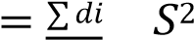 = 1 ∑𝑛 (𝑑 − 𝑑̅)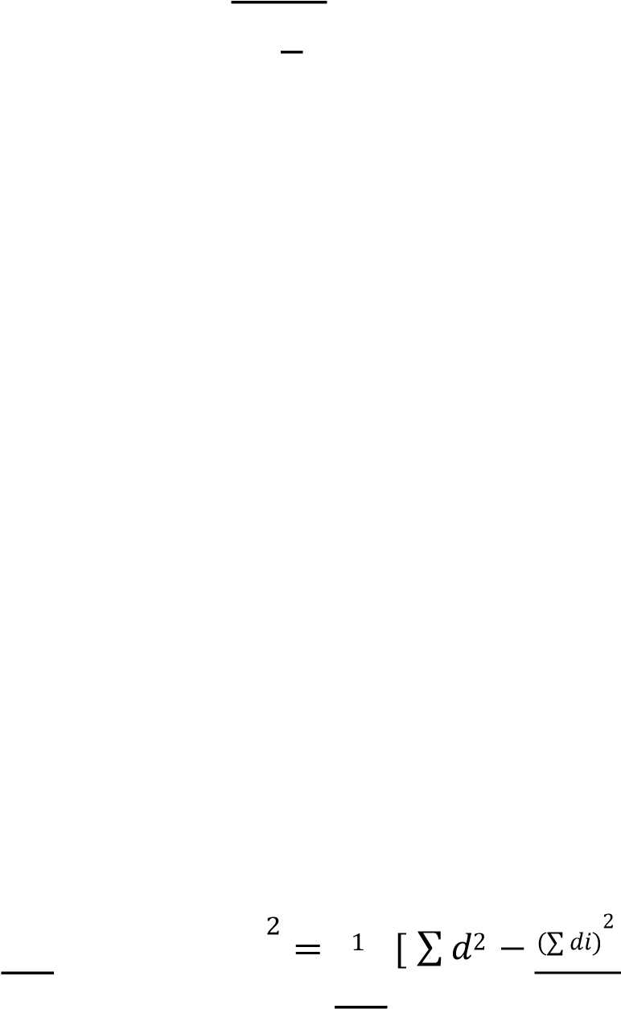] with 𝑛 − 1 𝑑𝑓

𝑛 𝑛−1𝑖=1 𝑖𝑛−1 𝑖 𝑛

## Case1. Test for single mean

Open the desired file in SPSS editor File > Open > file path

(car_sales.sav from repository is used and the variables Fuel efficiency is considered)

𝐻0 ∶ 𝐴𝑣𝑒𝑟𝑎𝑔𝑒 𝑖𝑠 23 𝑘𝑚/𝑙𝑡 or ( 𝜇 = 23 𝑘𝑚 𝑝𝑒𝑟 𝑙𝑡) 𝐻1 ∶ 𝜇 ≠ 23 𝑘𝑚 𝑝𝑒𝑟 𝑙𝑡)

Now follow the path Analyze > Compare Means > One Sample t-test

Assign the test value.

fix the confidence interval.

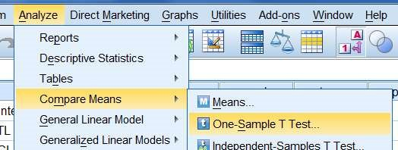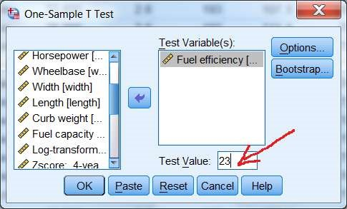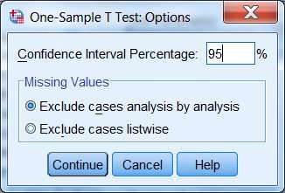

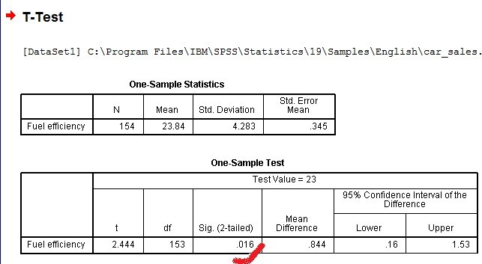

Note the p value is 0.016 which is less than the assigned value 0.05 hence null hypothesis is rejected, ie., claim 𝜇 = 23 𝑘𝑚 𝑝𝑒𝑟 𝑙𝑡 can not be accepted.

Case2. Test for difference of means

Open the desired file in SPSS editor File > Open > file path

(car_sales.sav from repository is used and the variables Fuel efficiency is considered for testing of means w.r.t. types of vehicle ie. Automobile & Truck )

𝐻0 ∶ 𝐹𝑢𝑒𝑙 𝑒𝑓𝑓𝑖𝑐𝑖𝑒𝑛𝑐𝑦 𝑜𝑓 𝐴𝑢𝑡𝑜𝑚𝑜𝑏𝑖𝑙𝑒𝑠 = 𝐹𝑢𝑒𝑙 𝑒𝑓𝑓𝑖𝑐𝑖𝑒𝑛𝑐𝑦 𝑜𝑓 𝑇𝑟𝑢𝑐𝑘𝑠 ( 𝜇𝐴 = 𝜇𝑇)

Now follow the path Analyze > Compare Means > Independent Sample test

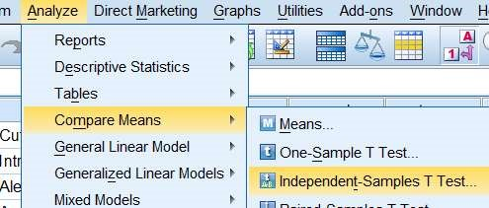

Transfer the the desired variable to test variable then transfer the variable w.r.t. which the means are to be tested (in present case Automobiles & truck are considered)

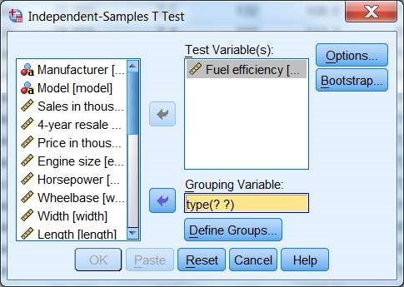

click define group

(Note: in the variable view the value can be assigned)

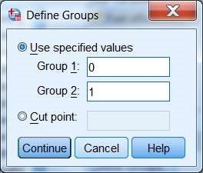

Enter the desired level of significance

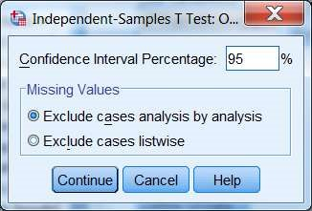

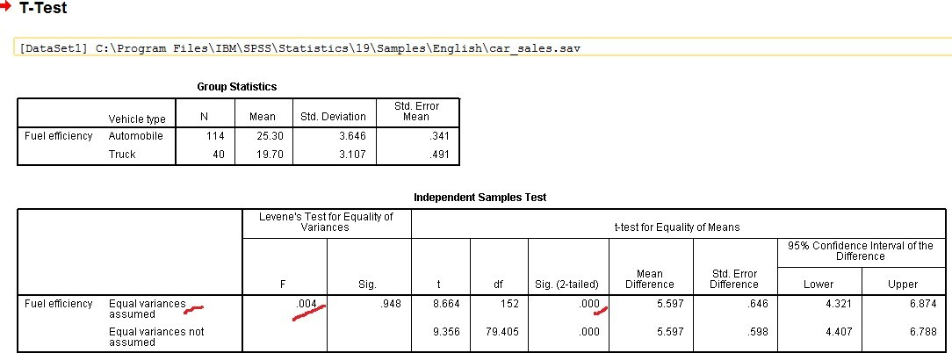

(Levene’s test is to decide the equivalence of the variances) in the present case in first row reading of p-value is 0.948 > 0.05 hence equivalence of variances can be accepted (Now we will read all information from first row). Also the for t-test p-value is almost zero <0.05 hence null hypothesis is rejected.

## Case3. Paired ‘𝑡’- test for difference of means

Open the desired file in SPSS editor File > Open > file path

(adexp_salesbefore & after.sav is used ) sales before & after the ad is to be tested.

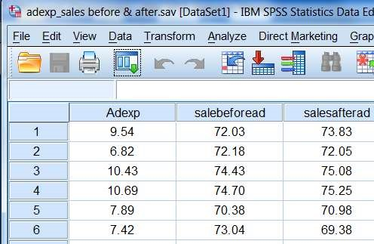

𝐻0 ∶ 𝑎𝑣𝑔 𝑠𝑎𝑙𝑒𝑠 𝑏𝑒𝑓𝑜𝑟𝑒 𝑎𝑑 = 𝑎𝑣𝑔 𝑠𝑎𝑙𝑒𝑠 𝑎𝑓𝑡𝑒𝑟 𝑎𝑑 ( 𝜇𝑏 = 𝜇𝑎) or { 𝜇𝑏 − 𝜇𝑎 = 0 }

Now follow the path Analyze > Compare Means > Paired-Samples T-test

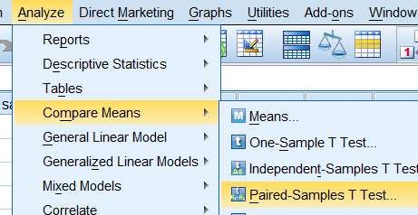

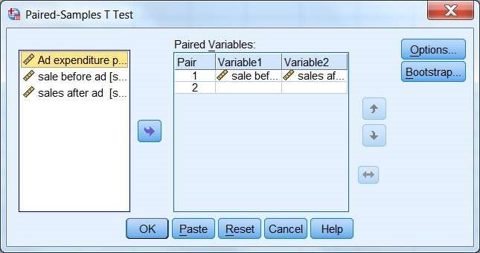

Transfer the testing variables (Sales before & sales after)

Click options

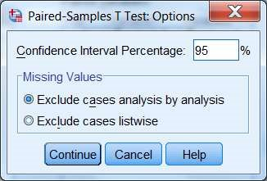

enter the desired level significance.

### Doc output window

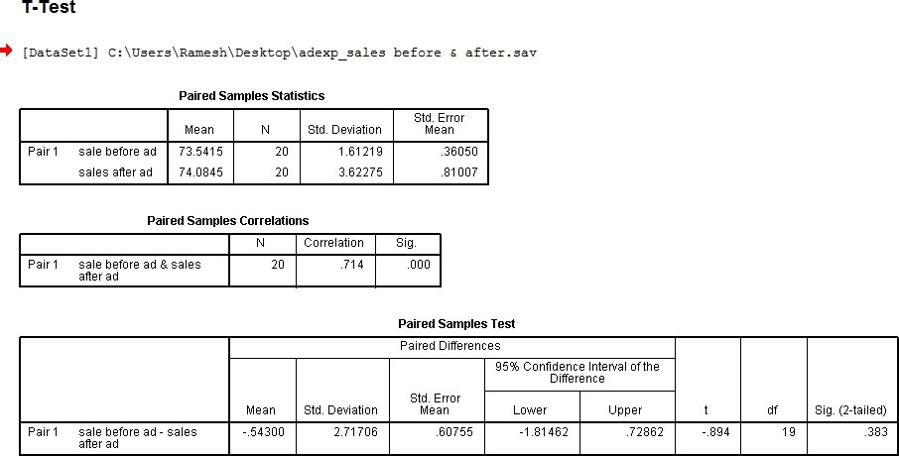

Since the p-value 0.383 which is greater than 0.05 ie, average sales befor and after ad does not differ significantly.Hence null hypothesis can not be rejected.

Conclusion:

Give information of data set used for testing. Also mentioning the p-value write the decision about rejection or non-rejection of null hypothesis.

Precautions:

1. Variable Properties are to be defined carefully.
2. Missing values if any should be taken care of.
3. Null hypothesis is defined carefully and level of significance chosen appropriately.

# Experiment - 9

Objective: Chi Square test

Resources: SPSS editor, Data Source file.

Theory And Methodology

Chi Square test in SPSS is test for association ( or independence ) of two nominal variables.

Case1. Chi-squared test of independence in contingency tables

A cell containing information of two characteristics resulting into a bivariate data. The table displaying data is called contingency table. Horizontal and vertical display of data is referred as 𝑟 × 𝑐 table.

Our interest is to see whether two characteristics are independent, thus 𝐻0: Two characteristics are independent. 𝐻1: they are dependent.

𝑂𝑖𝑗 ∶ observed frequency of ith row and jth column respectively.

𝑒𝑖𝑗 ∶ expected frequency of ith row and jth column respectively.

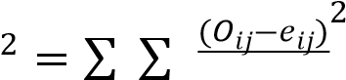Then

𝑆𝑜, 𝜒 with (𝑟 − 1) × (𝑐 − 1) degree of freedom

𝑖 𝑗 𝑒𝑖𝑗 (df).

Open the desired file in SPSS editor File > Open > file path

𝐻0: Fraudulent claims are independent of Gender

𝐻1: Fraudulent claim is Gender dependent

Now follow the path Analyze > Descriptive Statistics > Crosstabs

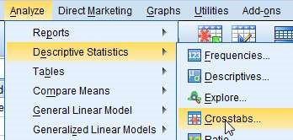

Transfer the desired variables in rows & column box (their order does not matter).

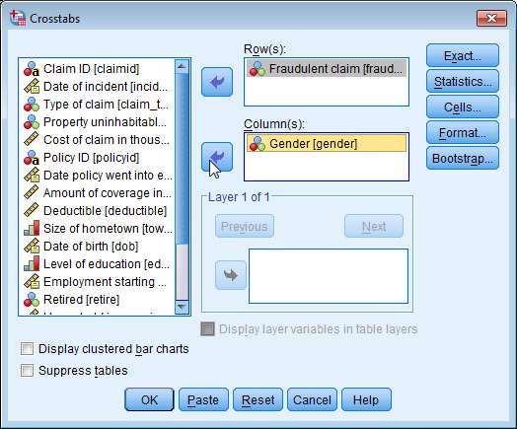

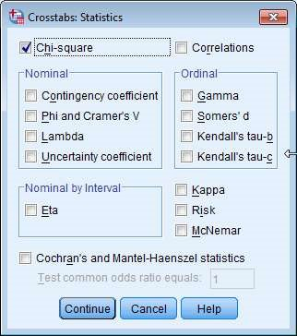

click continue. Then click Cells button

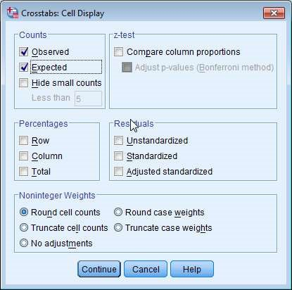

Observed (under count) is checked by default, select Expected.Then OK Doc output window

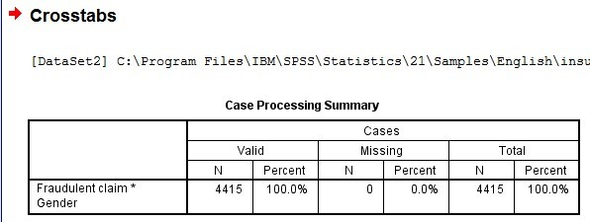

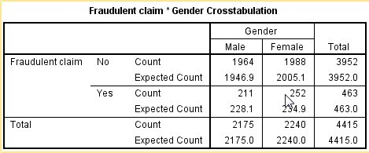

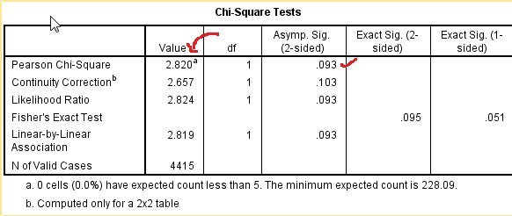

The Pearson Chi-Square p-value 0.093 is greater than 0.05 , therefore Null Hypothesis is not rejected. It is concluded thet fraudulent claim is not gender biased.

## Case2. Chi-square test for goodness of fit

If a population has a specified theoretical distribution. The test is based on how good a fit we have between the frequency of occurrence of observations in an observed sample and the expected frequencies obtained from the hypothesized distribution.

A goodness of fit test between observed and expected frequencies is based on the quantity

𝑘 (𝑂𝑖 − 𝑒𝑖)2

𝜒2 = ∑ ,

𝑖=1 𝑒𝑖

𝑂𝑖: observed frequency of the cell 𝑒𝑖: expected frequency of the cell cell : each possible out comes of the experiment.

Where 𝜒2 is a value of a random variable whose sampling distribution is approximated very closely by the Chi square distribution with 𝜈 = 𝑘 − 1 degree of freedom (df). Critical values

If the observed frequencies differ considerately from the expected frequencies, the 𝜒2 value will be large and fit is poor. A good fit leads to the acceptance of

𝐻0, where as a poor fit leads to rejection.

(insurance_claims.sav from repository is used and Claim type is considered)

𝐻0: Claims are equally distributed 𝐻1: It is not equally distributed

Now follow the path Analyze > Nonparametric Tests > Legacy dialogs > Chi Square

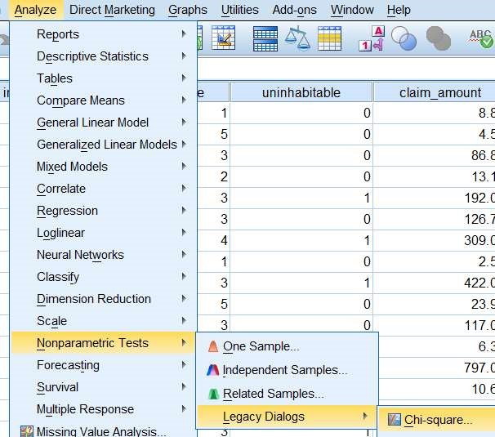

Transfer the desired variable to Test variable list box

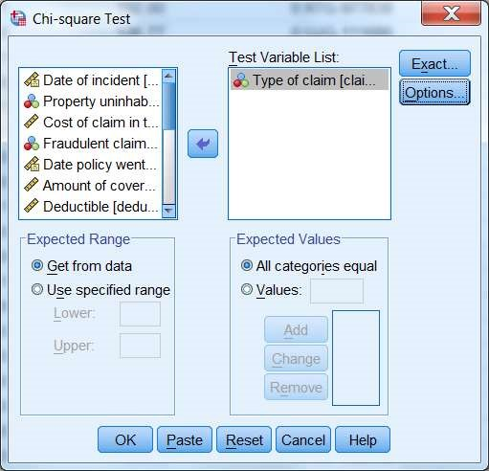

Click option and check the desired box (Descriptive under statistics)

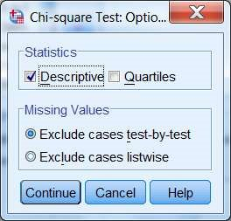 continue

Under Expected Values check the desired option (in present case all categories equal)

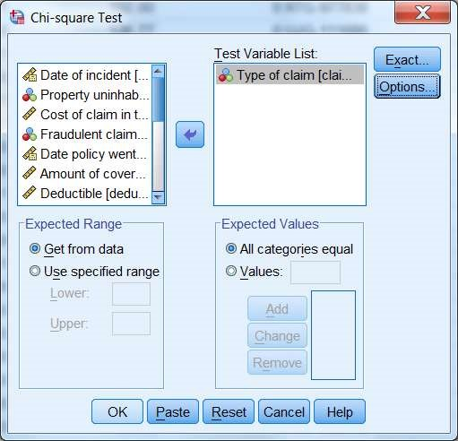

click OK

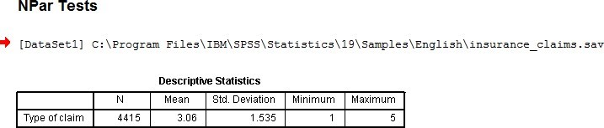

|  |  |
| --- | --- |
|  |  |

The Test Statistics shows the p-value almost zero which is less than 0.05, therefore the null hypothesis is rejected in favour of alternate, ie., type of claim are not equally distributed.

This can be visualised through graph also.

Double click the frequency table to bring into editable mode

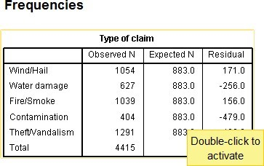

Select both the columns of observed & expected frequency and right click > Create Graph > Bar

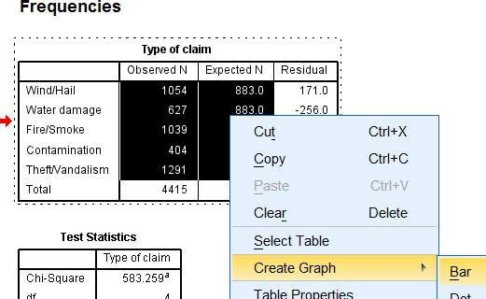

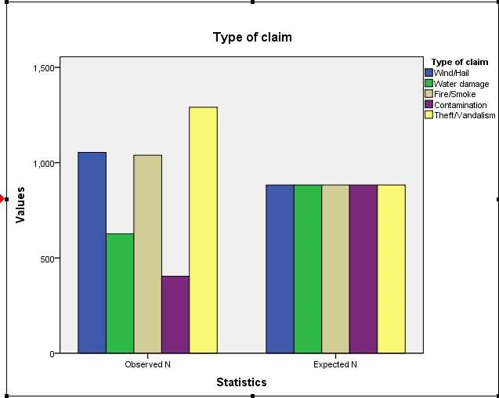

Conclusion:

Give information of data set used for testing. Also mentioning the p-value write the decision about rejection or non-rejection of null hypothesis. Precautions:

1. Variable Properties are to be defined carefully.
2. Missing values if any should be taken care of.
3. Null hypothesis is defined carefully and level of significance chosen appropriately.

# Experiment - 10

Objective: ANOVA One Way

Resources: SPSS editor, Data Source file.

Theory And Methodology

Let 𝑘 random samples of size 𝑛1, 𝑛2 … 𝑛𝑘 are selected from normal populations with mean 𝜇1, 𝜇2 … 𝜇𝑘, and common variance 𝜎2 . And let the means are depending on one factor then

One Way ANOVA is applied

𝐻0 ∶ 𝜇1 = 𝜇2 = ⋯ = 𝜇𝑘 and 𝐻1∶ at least two means are different.

Procedure: the total variation can be attributed to variation within the class and variation between the class.

Total sum of squares = Sum of square within the class + sum of square between the class

𝑇𝑆𝑆 = 𝑆𝑆𝐵 + 𝑆𝑆𝑊

The degree of freedom (df) for TSS is (𝑁 − 1), for SSB is (𝑘 − 1), & for SSW is (𝑁 − 𝑘). Now mean square (MS) for each variation is obtained by dividing each sum of square by its respective degree of freedom (df), i.e.,

𝑇𝑆𝑆 𝑆𝑆𝐵 𝑆𝑆𝑊

𝑀𝑆𝑆 = , 𝑀𝑆𝐵 = , 𝑀𝑆𝑊 =

𝑁 − 1 𝑘 − 1 𝑁 − 𝑘

The value of 𝐹 −statistic will be

∑𝑖 ∑𝑗 𝑛𝑖(𝑥𝑖. − 𝑥̅..)2 𝑁 − 𝑘

𝐹 = ∑𝑖 ∑𝑗(𝑥𝑖𝑗 − 𝑥̅..)2 ∗ 𝑘 − 1 , 𝜈1 = 𝑘 − 1, 𝜈2 = 𝑁 − 𝑘

Open the desired file in SPSS editor File > Open > file path

(insurance_claims.sav from repository is used and claim amount & Type of claim variables are considered) (see the data 5-types of claims are there)

𝐻0: average claim amount in each category is same. Ie., 𝜇1 = 𝜇2 = 𝜇3 = 𝜇4 = 𝜇5 𝐻1: At least one of these differs

Now follow the path Analyze > Compare Means >

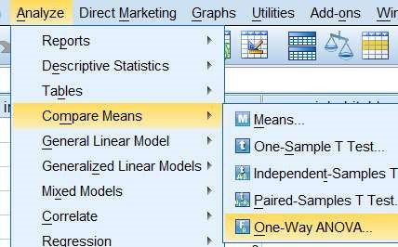

Transfer Cost of claim to dependent list and Type of claim to factor list

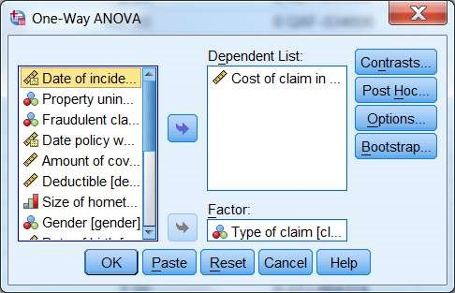

Click Option and select the Descriptive to display statistics

Continue & click OK.

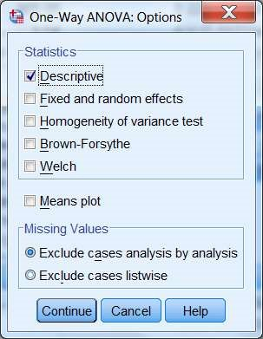

## Doc Output Window

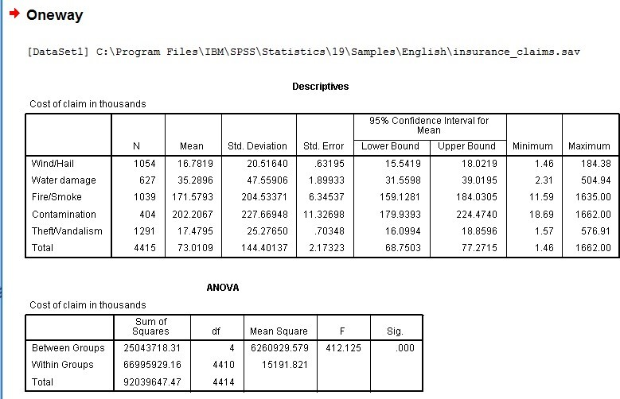

Since the p-value of F-statistics is almost zero which is less than 0.05, hence the Null Hypothesis is rejected, ie., at least one of the mean is different.

Conclusion:

Give information of data set used for testing. Also mentioning the p-value write the decision about rejection or non-rejection of null hypothesis.

Precautions:

1. Variable Properties are to be defined carefully.
2. Missing values if any should be taken care of.
3. Null hypothesis is defined carefully and level of significance chosen appropriately.

(Optional Procedure)

In case null hypothesis is rejected and you are interested to know which mean is different then

|  |  |
| --- | --- |
|  | Click Post Hoc.. |

Select Tukey & continue. Additional windows will open to show the results

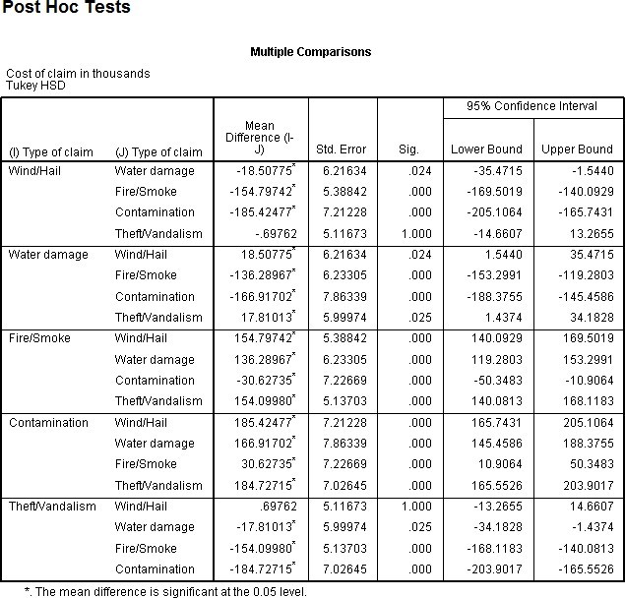

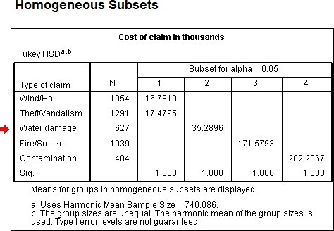

Look to the p-values and where ever it is less than 0.05 , difference is significant.

# Experiment - 11

Objective: ANOVA Two Way

Resources: SPSS editor, Data Source file.

Theory And Methodology

Open the desired file in SPSS editor File > Open > file path

(Printer9.sav is used)

𝐻0: average claim amount in each category is same.

𝐻1: At least one of these differs

Sample file

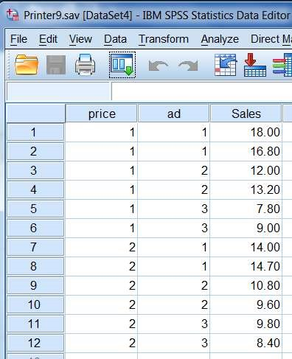

Now follow the path Analyze > General Linear Model > Univariate

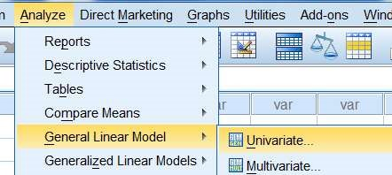

Transfer Sales in Thousand in dependent variable box and Price & Ad in Fixed factor box



click Model

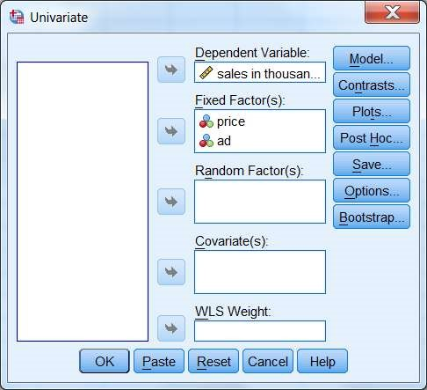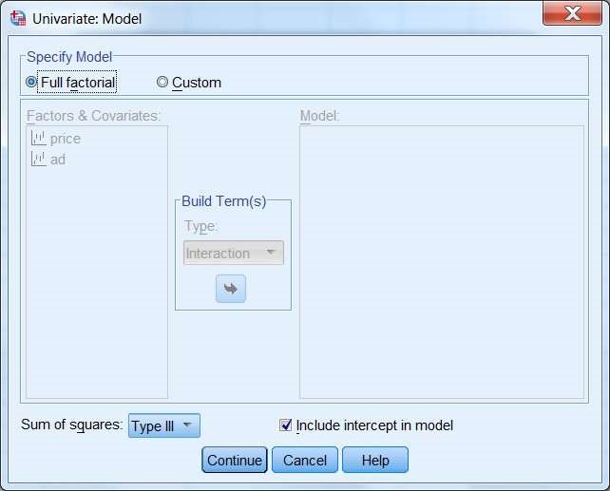

By default Full factorial is selected, need not to change.

Click Option button and choose the desired option, and continue.

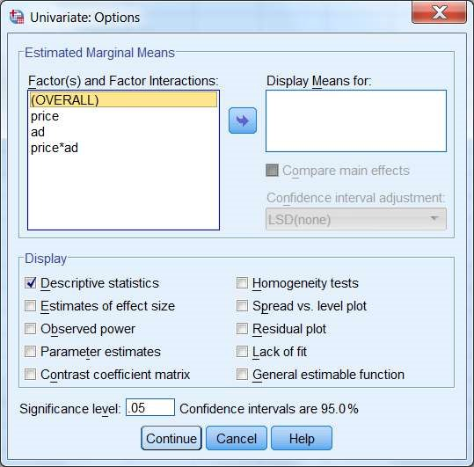

Click OK.

## Doc Output Window

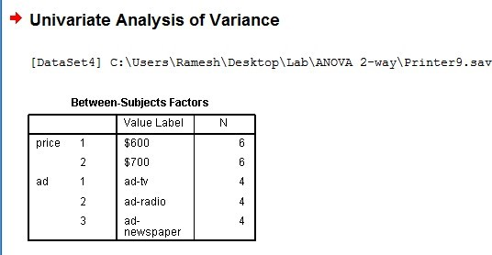

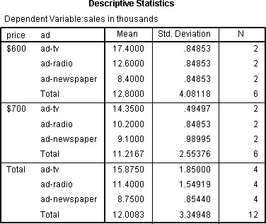

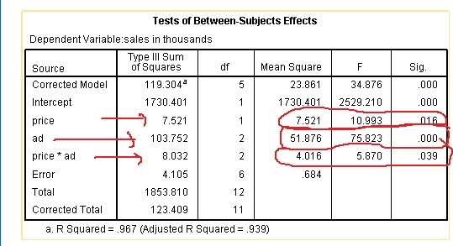

(Interpretation: The p-values along price and ad both are much smaller than 0.05, therefore Null Hypothesis is rejected for both the factors, ie., the average sales are not same along both the factors separately.)

Conclusion:

Give information of data set used for testing. Also mentioning the pvalue write the decision about rejection or non-rejection of null hypothesis.

Precautions:

1. Variable Properties are to be defined carefully.
2. Missing values if any should be taken care of.
3. Null hypothesis is defined carefully and level of significance chosen appropriately.